>node -v -> node installed

>npm -v -> npm installed

To intialize Project - execute below commands in the project terminal

1. install npm

> npm init

2.

npm install @wdio/cli -> should be 0 vulenerabilities

Note : anything installed with npm a entry will be made in package.json(same as pom.xml in MavenProject) and dependency is downloaded and stored in node_modules

3. once you installed CLI after

npx wdio config -> configuaration helper will start and ask questions to choose requirement

4. create tsconfig.json file and copy typescript json from terminal --> to see Autosuggestion while writing code

5. to run your test - npx wdio run test/wdio.conf.ts

[download cucumber extension to see format]

To create step definition

download -> Tidy Gherkin App and Open chrome://apps and open TD

copy and paste feature file into **TD** select JS Steps

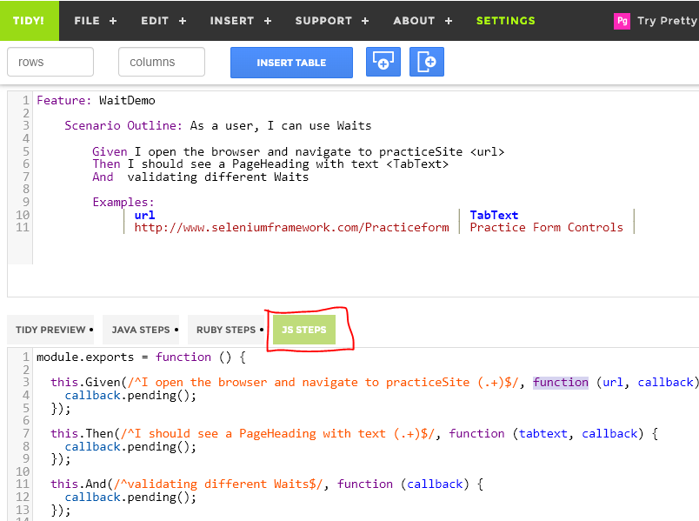

run specific test

wdio wdio.conf.js --spec ./features/step-definitions/WaitDemo.ts

View -> Extensions (to be installed)

